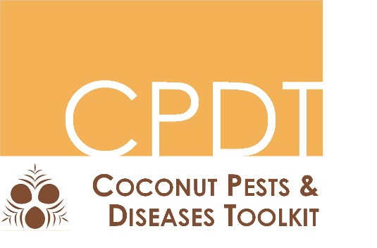
Coconut Pests & Diseases

Workbook

Funded by the European Union, through SPC, as part of Coconut Industry Development for the Pacific.
Workbook produced by Monica Gruber of Pacific Biosecurity, Victoria Link Limited, University of Wellington

  - 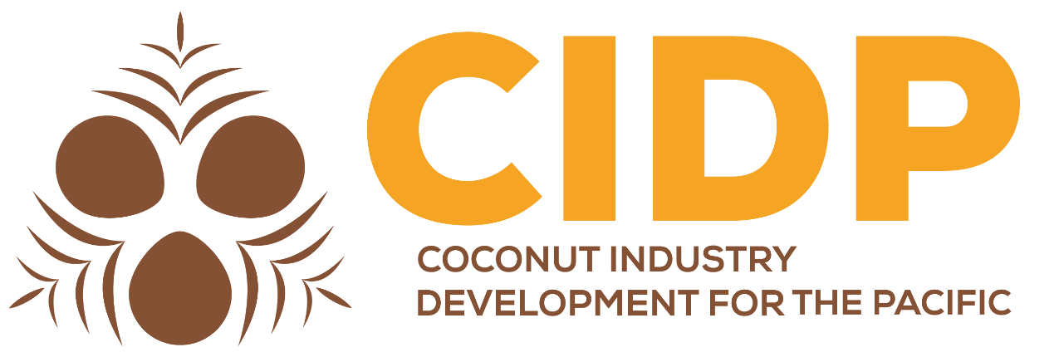
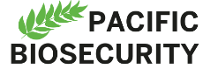



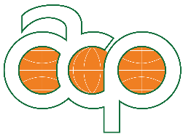

Contents
Introduction 3
Target audience 3
Objectives 3
Workshop duration 3
How to use this workbook 3
Provisional workshop schedule 4
Day one 5
Introduction: Finding your way around the Coconut Pests & Diseases Toolkit 5
Getting started 5
Finding your way – the main sections 6
Finding your way – footer sections 7
Finding your way – the search function 8
Finding your way – navigation aids 8
Exercise 1: Introduction to pests and diseases of coconut 9
Group Activity – Pest / disease recognition and horizon scanning 9
Exercise 2: Recognising symptoms 10
Group Activity – observing symptoms 10
Day two 13
Exercise 3: Finding more information to identify pests and diseases 13
PestNet – joining and asking questions 13
WhatsApp - Signing up to the SPC group and starting your own group 17
Installing the Pacific Pests and Pathogens app 18
Exercise 4: Key pest and disease threats to the Pacific 19
Group Activity – finding information on pests and diseases 20
Day Three 29
Exercise 5: Prevention is key! 29
Individual Activity – Pest & disease distributions 30
Group Activity – finding information on prevention 32
Exercise 6: Practical prevention 34
Group Activity – practical prevention of CRB 34
Day four 38
Exercise 7: Pest and disease control 38
Group Activity – methods and barriers to pest control 38
Exercise 8: Diversity and resilience 41
Group Activity – the importance of diversity 41
Exercise 9: Community awareness 44
Small Group Activity – create a poster to raise awareness 44
Version control 46

Introduction
Participants will learn how to use the Coconut Pests & Diseases Toolkit to find out information on identification, prevention and control of pests and diseases of coconut. Participants will gain knowledge of the pests and disease that are a threat within, and to, the Pacific, so that they can pass this knowledge on to farmers and the wider community.

Target audience
The Coconut Pests & Diseases Toolkit workshop is intended for Agriculture and Biosecurity staff, farmers and others who are asked to provide, or need, advice on crop pests / diseases.
Ideal participants are people who are able to train others, have some background in pest and / or disease management, and have the time and resources to promote training into their communities.
As a minimum requirement, the participants should have a background in agricultural science and have a working understanding of topics such as basic epidemiology, classification of living things and insect and disease life-cycles.

Objectives
By the end of this workshop participants will have increased knowledge of pests and diseases of coconut to share with others through:
- Understanding the difference between pests and a diseases - and why the difference is important
- Knowing how to recognise symptoms of pests / diseases to assist identification
- Knowing where to get help and find more information on identification of pests / diseases
- Knowing the key pests and disease threats to the Pacific, their potential impacts and distribution
- Understanding the importance of prevention
- Knowing practical ways to prevent pests and diseases
- Knowing practical ways to control key pests and diseases
- Understanding the importance of diversity to resilience
- Thinking about ways that good community awareness can help prevent and control diseases and pests
Each objective has an exercise associated with it.

Workshop duration
Approximately 3-4 days – depending on availability of field sites. The aim is to have theory / indoors practical work in the mornings and field activities after lunch.

How to use this workbook
The purpose of the workbook is to guide the participants through using the toolkit and provide a record of training.
This workbook is organised into exercises that are designed to fulfil the objectives of the workshop. The facilitator will guide you through each exercise. Within each exercise, there are spaces to write your comments or answers to questions. All the exercises are supported by group and individual activities, giving opportunities for everyone to have their thoughts heard. The outcomes of group and individual activities will be discussed in the workshop.
You can also work through the workbook independently of participating in a workshop. If you are working through the workbook alone, there are instructions on how to find information on the Coconut Pests & Diseases Toolkit website.
When screen examples are shown in the workbook you’ll see a red box to highlight specific information mentioned in the text. Naturally these boxes don’t appear on the real web pages.

Provisional workshop schedule (Apia 22-25 October 2018)

Day one
Time | Topic
0900-1030 | Formal Welcome
1030-1100 | Break
1100-1130 | Introduction: Finding your way around the Coconut Pests & Diseases Toolkit website
1130-1230 | Exercise 1: The difference between pests and diseases
1230-1330 | Lunch
1330-1430 | Exercise 2: Recognising symptoms
1430:1700 | Field visit to a site or sites that has coconut with symptoms, to enable identification of possible causes in the field. Participants should bring a camera or smartphone / tablet with camera.  We will also put up traps for Coconut rhinoceros beetle, in preparation for another field exercise later in the week.

Day two
Time | Topic
0900-0930 | Recap and plan for the day
0930-1030 | Exercise 3: Finding more information to identify pests and diseases
1030-1100 | Break
1100-1230 | Exercise 4: Key pest and disease threats to the Pacific
1230-1330 | Lunch
1330-1400 | Exercise 4: Key pest and disease threats to the Pacific (continued)
1400-1700 | Visit to Apia agriculture show.

Day three
Time | Topic
0900-0930 | Recap and plan for the day
0930-1030 | Exercise 5: Prevention is key!
1030-1100 | Break
1100-1230 | Exercise 6: Practical prevention – CRB focus
1230-1330 | Lunch
1330-1700 | Practical prevention and pest and disease control - field exercise to be confirmed – assessing preventive measures in the field

Day four
Time | Topic
0900-0930 | Recap and plan for the day
0930-1030 | Exercise 7: Pest and disease control
1030-1100 | Break
1100-1130 | Exercise 7: Pest and disease control (continued)
1130-1230 | Exercise 8: Diversity and resilience
1230-1330 | Lunch
1330-1430 | Exercise 9: Community awareness
1430-1600 | Field exercise to be confirmed - revisit Coconut rhinoceros beetle traps.
1600-1630 | Workshop assessments and wrap-up

Day one

Introduction: Finding your way around the Coconut Pests & Diseases Toolkit
Duration: 0.5 hours
Objective: Know how to access the Coconut Pests & Diseases Toolkit online and offline
The Coconut Pests & Diseases Toolkit is found online at http://coconutpests.org//. The website can also be used ‘offline’. Workshop participants will be provided with ‘offline’ versions on a USB. When you have no internet connection you can still use the toolkit with the USB version. The information will mostly be the same, although the online toolkit will be up-to-date.

Getting started
- To access the online version of the toolkit:
Open a web browser and type coconutpests.org into the browser address bar.
- To access the ‘offline‘ version of the toolkit:
Insert the USB provided into your computer. You can copy the contents of the USB onto your computer (that will take a while as there are a lot of files, so do that in the ‘background’ while you are working on exercises online).
There are several ways to access the toolkit, and this will differ depending on how your computer is set up.
- Look at the contents of the USB using Windows Explorer
- Click on the file called index.htm. On some computers the file might just be called index.
- The file should open in your browser. You can then use this just like any other website. You will notice that instead of having an address in the browser bar similar to the screenshot below:
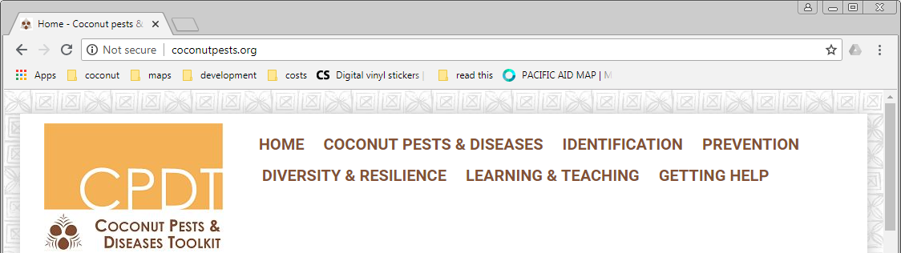

The address bar will have a ‘file’ address similar to the screenshot below:
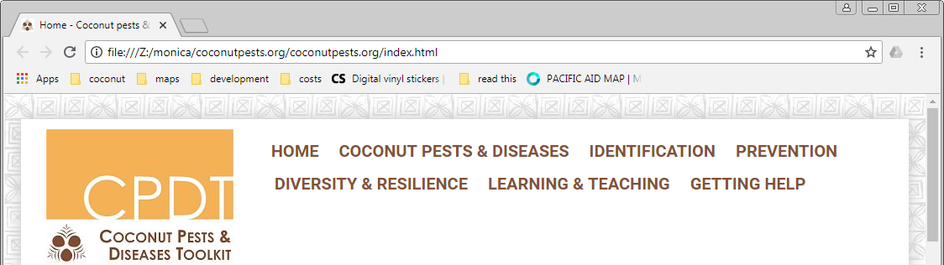

If the file does not open in your browser it might be because your browser is not set as the default to open these types of files. Ask the facilitator to help if you have problems.
Make notes to remind you about problems that some people might have in accessing the toolkit. If you will be training others you need to be prepared.

Finding your way – the main sections
You’ll see from the navigation bar at the top of the page that the website has six main sections (as well as the link back to the HOME page):

- COCONUT PESTS & DISEASES: the potential pests and diseases affecting coconut. Those causing more severe problems are described in more detail.
- IDENTIFICATION: identify possible pests or diseases using the symptoms that are observed
- PREVENTION: general approaches to prevention (biosecurity)
- DIVERSITY & RESILIENCE: global change, its effects on coconut production, and ways to minimise these effects
- LEARNING & TEACHING: resources for awareness and training
- GETTING HELP: as well as the resources in the CPDT, technical experts, regional agencies and NGOs can help you
Click on each of the sections and glance over the information in the section. We’ll go into more detail on these sections later in the workshop.

Make notes here:
Some sections have sub-sections, which you can see as a drop-down list when you ‘hover’ your mouse over the section name in the navigation bar as shown below.
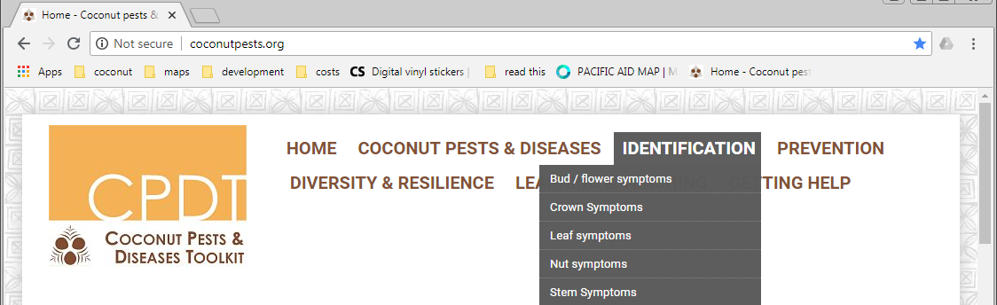

Finding your way – footer sections
If you scroll down, at the bottom of every page, you'll find links to CREDITS, a GLOSSARY, and a SITE MAP that provides an overview of content in the site.
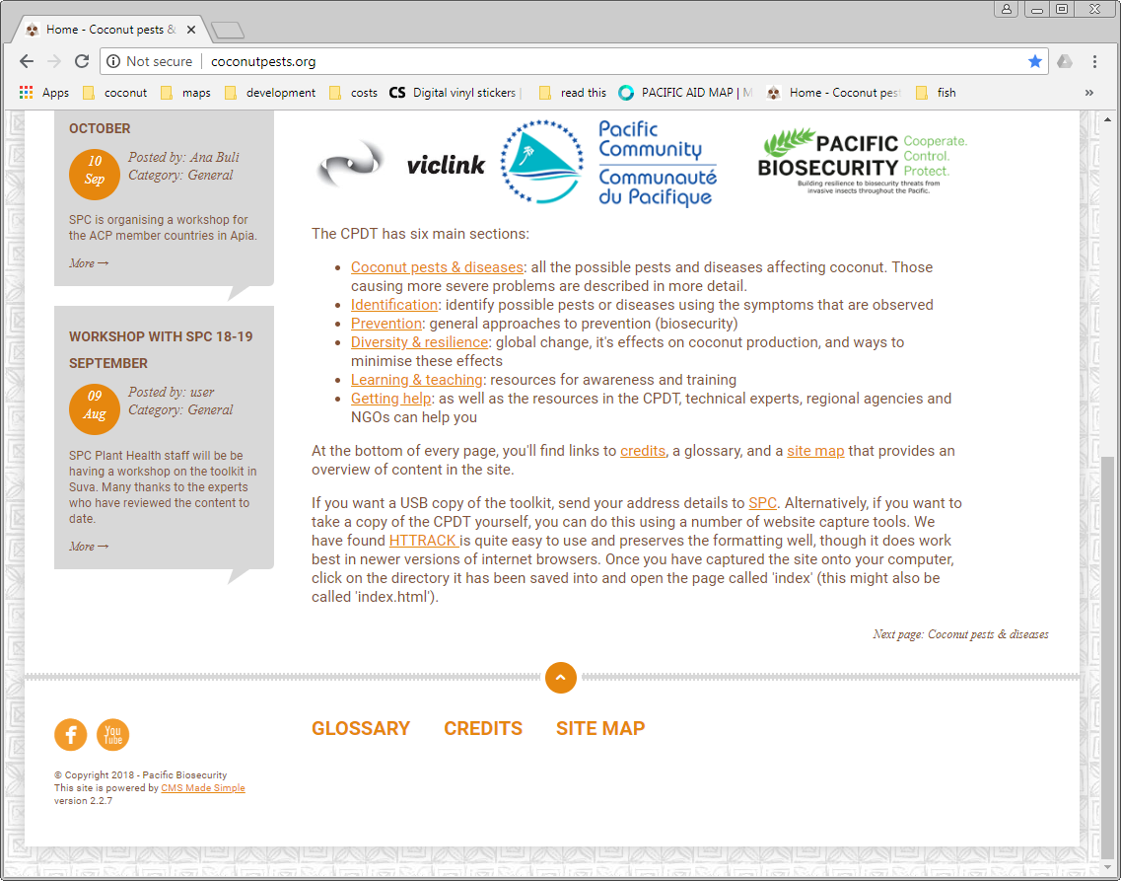

The small arrow above the links at the bottom of the page is a link back to the top of the page: There are also 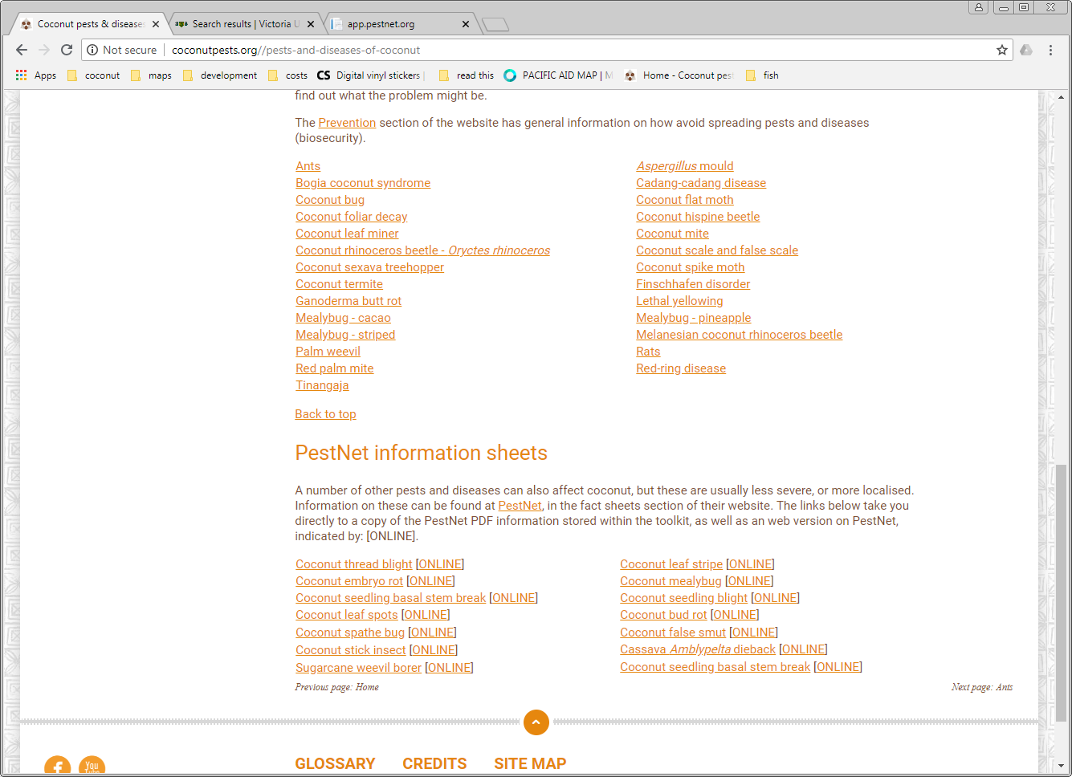links throughout the pages between sections of material.

Finding your way – the search function
Back at the top of the page is a search function (the search bar) that will search the whole site for a search term that you type in. It will look for exact matches only, so you need to enter full words.
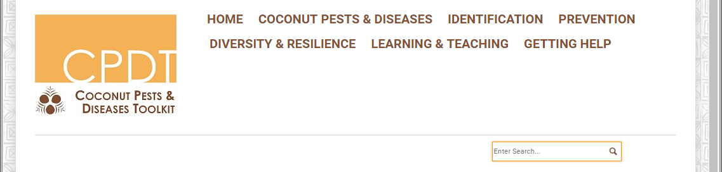
The search function works in the online version only.

Finding your way – navigation aids
The toolkit has navigation aids to help you find out where you are in the website.

‘Breadcrumbs’
Website pages have a hierarchical structure i.e., pages within sub-sections, within sections. You saw this when you hovered over a section with a drop down list. When you are on a page within a sub-section, the position of the page will be shown just below the search bar. These are called breadcrumbs because you can use them to find your way back to the top level of the of the site hierarchy i.e., the Home page.

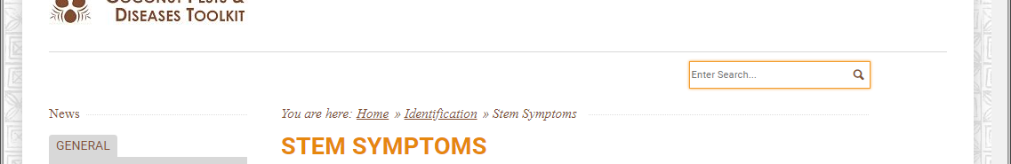

Previous / next page
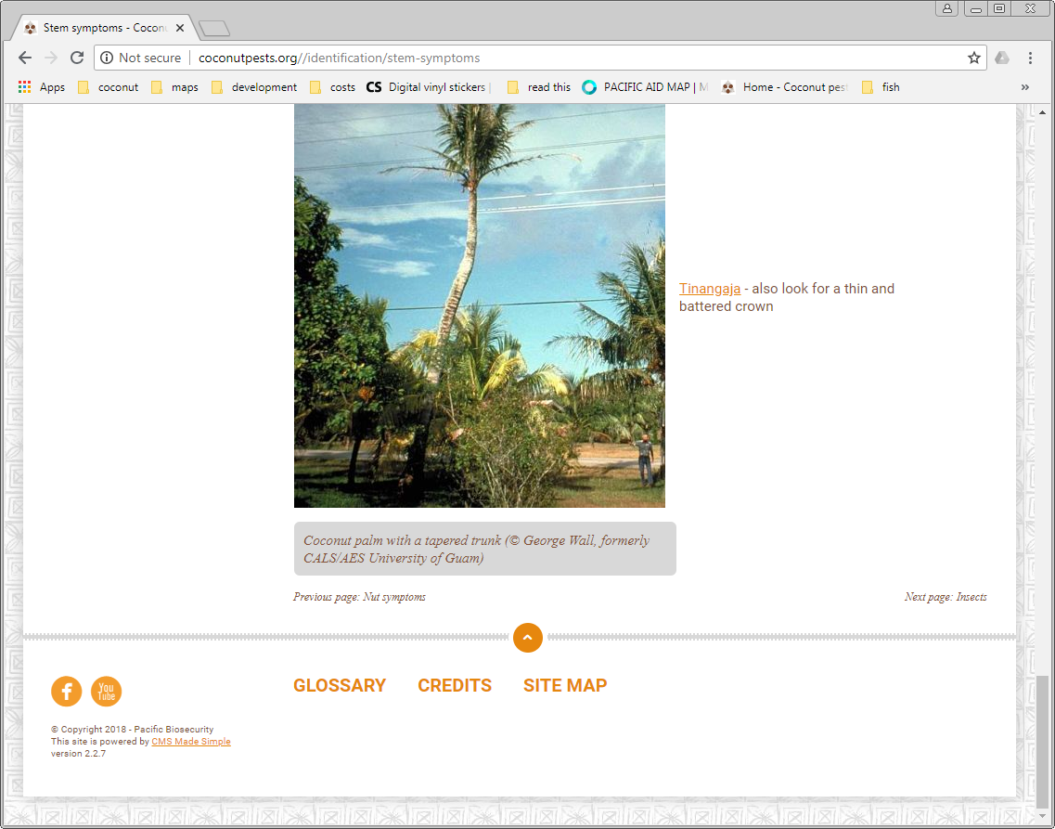
At the bottom of the page, above the footer sections, you’ll see on the left there are indicators for the previous and next pages i.e., and . This means you can read through the website as though it were a book, looking through all pages within a sub-section and then moving on to the next section.

Next we will look at key sections in more detail.

Exercise 1: Introduction to pests and diseases of coconut
Duration: 1 hour
Objective: Understand the difference between pests and diseases - and why the difference is important
Click on the COCONUT PESTS & DISEASES section heading in the navigation bar.
You will see there are three main areas on this page:
- What is the difference between a pest and a disease and why does it matter?
- Information on pests and diseases
- PestNet information sheets

Group Activity – Pest / disease recognition and horizon scanning
Break up into groups of 4-5 people. Talk through the information in the paragraph: What is the difference between a pest and a disease and why does it matter?
Have a look at the list of pests and diseases in the Information on pests and diseases paragraph, and the images handed out to you (a collage of some pest and disease images). Work as a group to fill out the sheet provided (30 minutes). You will present this to the workshop at the end of the exercise.
Think about and discuss:
- What pests / diseases are common where you live?
- From what others in your group have said, and what you know about your trading partners (or neighbours or other regions in your country), which pests and diseases should you be concerned about preventing (horizon scanning)?
Make notes here:
  - Pests / diseases where I live
  - Pests / diseases I should be concerned about
Present your group’s findings. Once you have presented your group’s information to the workshop, discuss as a whole group which we think are the highest priority for prevention and why.
We’ll return to look at parts of the COCONUT PESTS & DISEASES section in detail later. Let’s look at symptoms – these are often the first sign of problems.

Exercise 2: Recognising symptoms
Duration: 1 hour plus field visit
Objective: Know how to recognise symptoms of pests / diseases to assist identification
Click on the IDENTIFICATION section in the navigation bar.
You will see the main page that introduces you to the section.
As well as information on symptoms seen in the plant, there is also information on identifying the insects and animals that can affect coconut.
Hover your mouse over on the IDENTIFICATION section heading in the navigation bar.
You can see the sub-sections. Click on one of the sub-sections.
You will see there are images of various symptoms, a description of the symptom, and each image has a link to the possible cause. For higher priority pests, we have provided links to other symptoms also, and information on what else the symptoms could indicate.

Group Activity – observing symptoms
Break up into 4 groups of 4-5 people, depending on the number of people at the workshop, and the time available (as there is much more information for insects and leaf symptoms, the 4 groups suggested are: 1= leaf symptoms; 2= insects, 3=stem symptoms & crown symptoms, 4=nut symptoms).
Each group will work through a set of symptoms (e.g. leaf symptoms). Look at the images provided. From the information in the IDENTIFICATION section, can you identify the potential pests and / or diseases responsible for the symptoms?
Once you have provisional identifications (30 – 40 minutes), report back to the workshop group.
Points to think about and discuss with the workshop group:
- How might you determine the actual cause when symptoms are similar?
- What are some other causes of symptoms such as leaf yellowing, drying of leaves, early nut fall?
- Have you noticed any of the symptoms in coconut in your area?
- Can you identify the cause from only the information provided? If not, what else do you need?
Make your own notes for each section below:
  - Leaf symptoms notes
  - Bud/flower symptoms notes
  - Crown symptoms notes
  - Nut symptoms notes
  - Stem symptoms notes
  - Insects notes
  - Animals notes

Day two
Recap from Day One.
- Pest / disease recognition and horizon scanning.
- Recognising symptoms – share images from field exercise.

Exercise 3: Finding more information to identify pests and diseases
Duration: 1 hour
Objective: Know where to look to find information on identification of pests / diseases
Although the toolkit will help you with identification, nothing can replace expert knowledge and experience. We are really fortunate to have a number of ways of getting help from experts.
Click on the GETTING HELP section in the navigation bar. You will see three main areas on this page:
- Local primary contacts and regional agencies: the regional CROP agencies are mandated to assist with managing pests and invasive species in the Pacific. Agencies include SPC and SPREP.
- Websites, forums, apps and blogs: online forums can put you in contact with a wider range of experts that may be able to help.
- Technical experts: technical experts will be able to provide you with advice on identification, prevention and management of coconut pests and diseases.
In this exercise we will focus on:
- Finding information using PestNet. At the time of writing PestNet was in the process of moving to a new system, so this exercise may differ from what was provided earlier.
- Joining the SPC WhatsApp group – and how to set up your own group.
- Adding the Pacific Pests and Pathogens app to your phone or other mobile device.

PestNet – joining and asking questions
There are two main areas in PestNet – the e-mail network and the factsheets. Today we will focus on the e-mail network. First let’s check out the PestNet website to find out how to sign up to the network.
  - PestNet notes

Open a new browser window and type www.pestnet.org into the browser address bar. The home page will appear.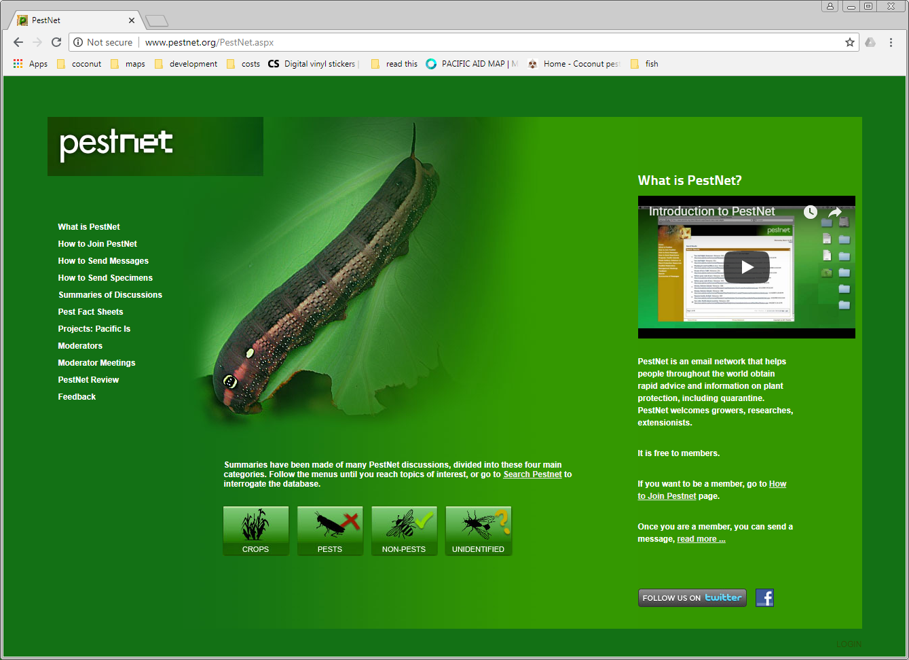

You’ll see there is an introductory video that you can look at later.
Let’s skip ahead to How to join PestNet. You’ll see the following page.
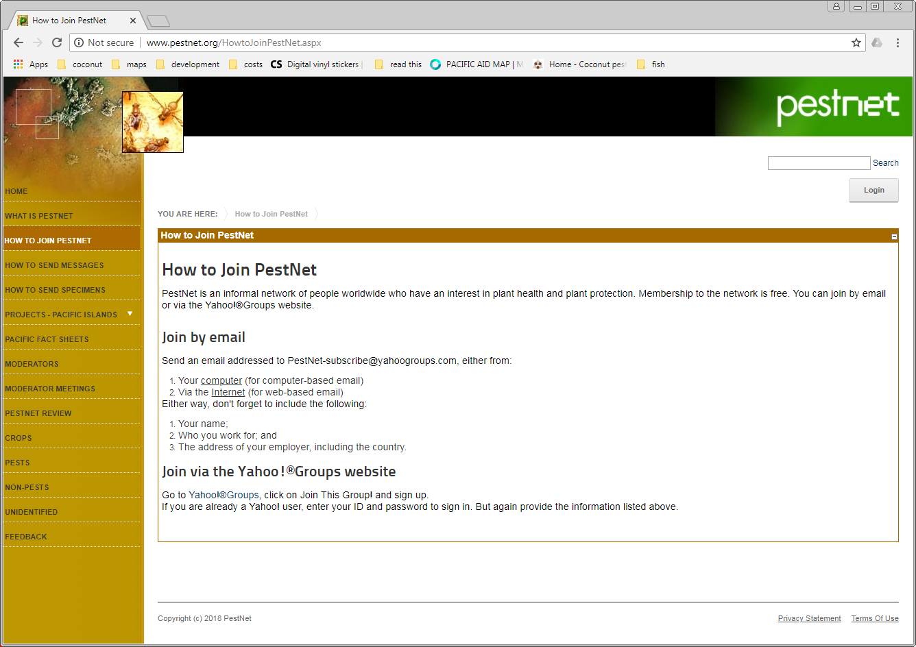
Do not join PestNet using the Yahoo!®Groups website. This is no longer being used.
Send an e-mail to PestNet-subscribe@yahoogroups.com to subscribe to the list. You will receive a confirmation. Now you can start asking questions, by simply e-mailing pestnet@yahoogroups.com. Contact Grahame Jackson <grahamejackson@gmail.com> if you have any problems or don’t receive responses.
  - PestNet notes
To ask questions on PestNet we need to go to the new PestNet ‘app’. You can also use this on a smartphone or tablet, as well as your computer.
Open another new browser window and type app.pestnet.org into the browser address bar. The below home page will appear.
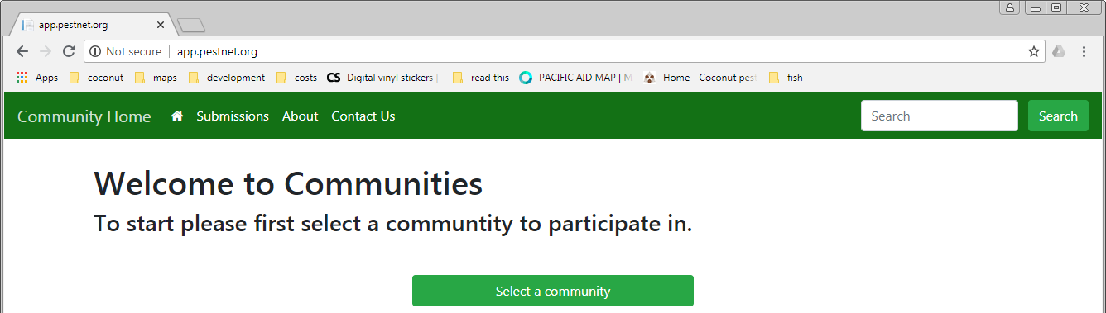

Click on the box: Select a community. From the page below click on the Visit community box for PestNet.
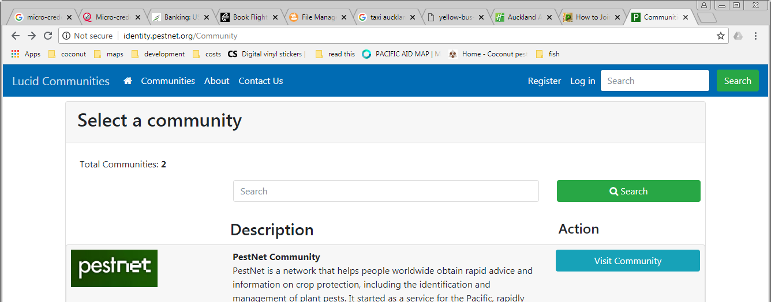

You will need to register to be able to post information through the app. Follow the instructions on the registration page and then Log in.
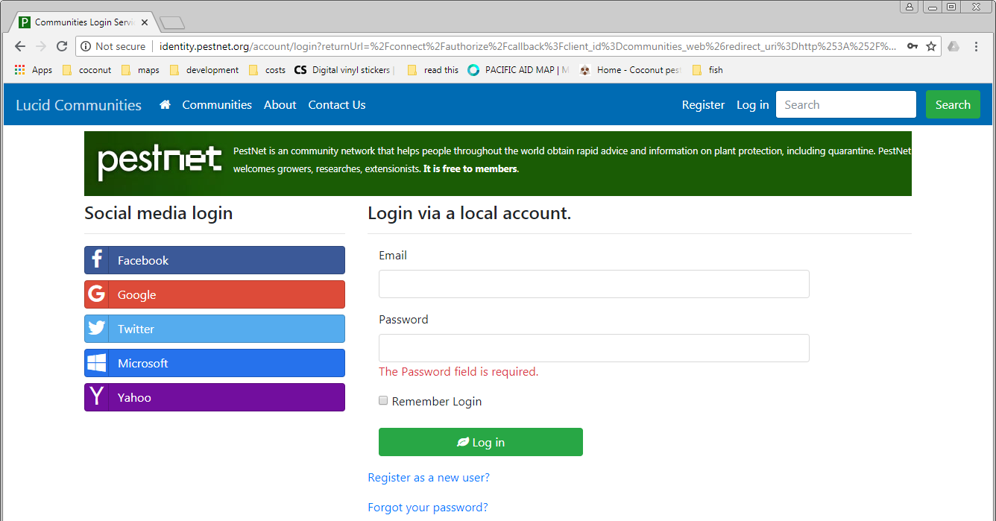

You will then see the submissions list screen:
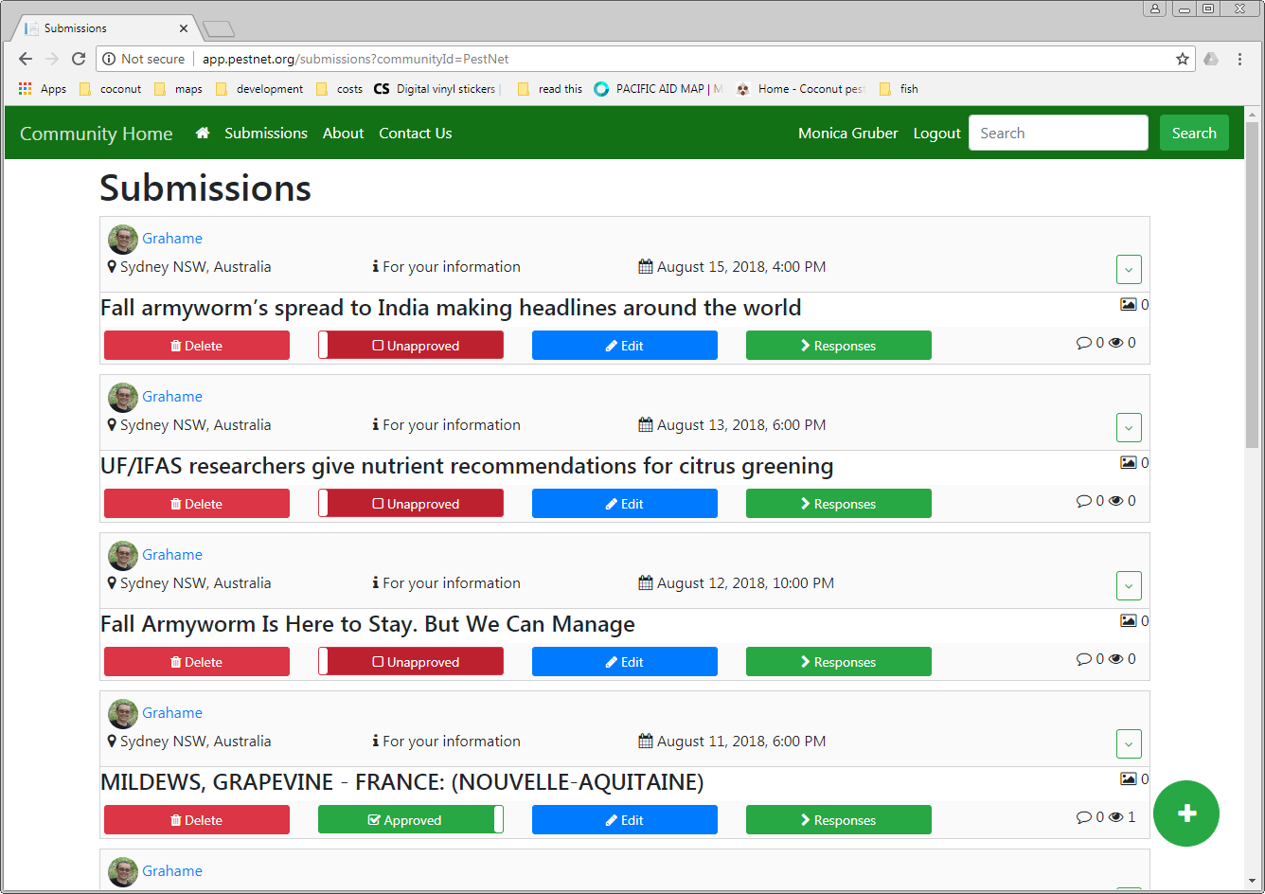

Click on the icon to add a question.
The submission form will appear. Fill out the details (when you have a question to ask – we won’t do this now). The question will be sent to the moderator.
You can browse through the submissions to see what other people have asked, and there is a search function to find past posts.
  - PestNet notes

WhatsApp - Signing up to the SPC group and starting your own group
WhatsApp is a free messaging service app. At the workshop members of the SPC Plant Health team can provide information on how the WhatsApp group is used. And if participants at the workshop belong to the group, they can also share stories about how they use it.
You can set up a new group, or ask to join an existing group. Provide your contact details to the SPC team (or email lrdhelpdesk@spc.int) to join the Fiji Plant Health Doctors group.
You can use WhatsApp on your smartphone, tablet, laptop or desktop computer. Go to Google Play Store or the Apple App Store to find the app and install it on your mobile device.
You need to have the app installed on your phone / tablet if you want to use it on your computer. You can download the computer version at https://www.whatsapp.com/. Follow the instructions to set up the app on your computer. But please don’t download a new installation pack while you are in the workshop! You can find installation packs for Mac, Windows 64 and Windows 32 on your USB.
  - WhatsApp notes

Installing the Pacific Pests and Pathogens app
One of the sources of information for the Coconut Pests & Diseases Toolkit are the PestNet Pacific Pests factsheets. These factsheets are available in the Pacific Pests and Pathogens app
Go to Google Play Store or the Apple App Store to find the app and install it on your mobile device.
Once you have installed the app, have a look through the fact sheets for coconut pests and diseases (Browse Fact Sheets).
Using the symptoms we studied yesterday (or even better, the images you took on our field visit), see if you can identify one of the pests / diseases with the app.
  - Pacific Pests and Pathogens app notes

Exercise 4: Key pest and disease threats to the Pacific
Duration: 2 hours
Objective: Know the key pests and disease threats to the Pacific, their potential impacts and distribution
In this exercise we will look at the COCONUT PESTS & DISEASES section more closely. In the time available to us we will only cover a selection of key pests and diseases. You can find out more about others in your own time. The toolkit will always be there as a reference for you.
Hover over the COCONUT PESTS & DISEASES section heading in the navigation bar. The list is in alphabetical order according to the common name of the pest or disease.
The 11th item on the drop-down list is Coconut rhinoceros beetle - Oryctes rhinoceros. This is one of the most widespread and damaging pests. Moreover, a newly discovered haplotype (or genetic form) is not susceptible to the bio-control virus isolate (virus genetic form) that is used for control.
Click on Coconut rhinoceros beetle - Oryctes rhinoceros in the drop-down list. The screen below will appear. Information is provided about:
Life-cycle and identification (or details of vectors for the diseases). Each of these topics has their own link near the top of the page.
- Symptoms.
- Impacts.
- Distribution.
- Prevention.
- Controlling the pest/disease.
- Information sources and further reading.
The information on most of the COCONUT PESTS & DISEASES pages is organised in a similar way to this.
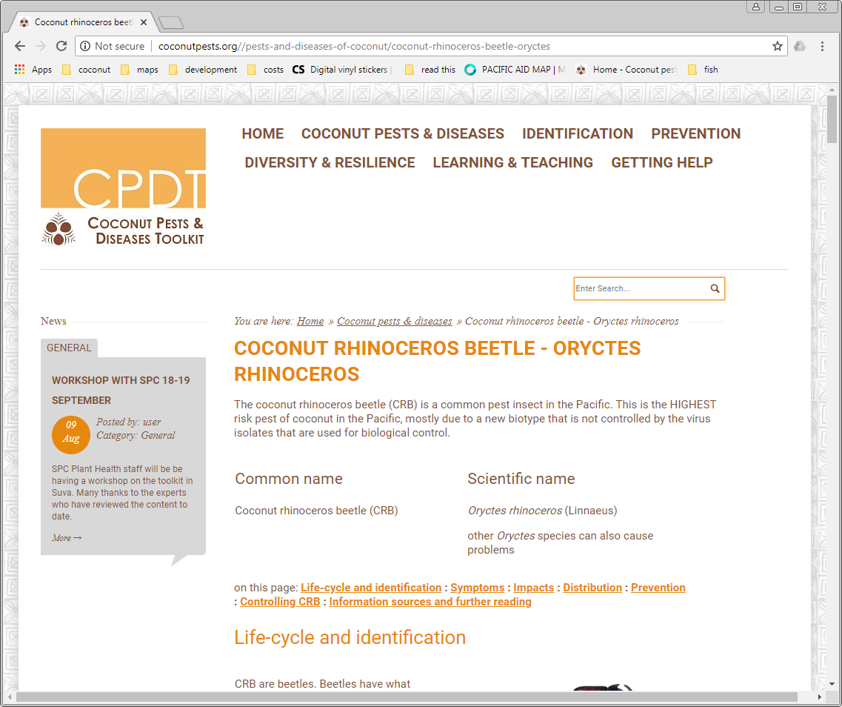

  - Notes
We don’t have time to work through the information on all the pages, but we want you to be familiar with the type of information on the pages.

Group Activity – finding information on pests and diseases
We will have another group exercise, where you work together to find out information about some selected pests and diseases:
- Coconut rhinoceros beetle – Oryctes rhinoceros.
- Bogia coconut syndrome.
- Red ring disease.
- Coconut foliar decay
These 4 have been chosen to provide a mix of different pests / disease scenario: present in the Pacific or not present; widespread or limited; pest or disease or combination!
We will take half an hour to work through each of the 4 topics (if time is short, we might only be able to cover three). Each group will look at the different aspect of the pest or disease e.g. life-cycle, symptoms etc., and make note of the key information.
Break up into 4 groups of 4-5 people, depending on the number of people at the workshop, and the time available.
For each pest / disease, first read through the introductory information at the top of the appropriate page in the COCONUT PESTS & DISEASES section.
As there is much more information for life-cycle and less for impacts and symptoms, the 4 initial groups suggested are: 1= life cycle and identification / vector insects; 2= distribution and prevention, 3=symptoms, 4=impacts). We will rotate the groups so that everyone has the chance to see how the information in each sub-section is described.
We will cover the information on control in Exercise 7.
Once you have made notes as a group (15-20 minutes), you will report back to the workshop group (10 minutes).
If you like you can make your own notes for each section below, based on your own group’s work and the work of other groups.

Coconut rhinoceros beetle - Oryctes rhinoceros

Life cycle
Read through the life-cycle and identification notes. What is the key information on the life-cycle?
Coconut rhinoceros beetle - Oryctes rhinoceros life-cycle and identification notes

Symptoms
Read through the symptoms notes. What is the key information on symptoms?
Are there differences between biotypes?
  - Coconut rhinoceros beetle - Oryctes rhinoceros symptoms notes

Impacts
Read through the impacts notes. What is the key information on impacts?
Are there differences between biotypes? Why is this important?
  - Coconut rhinoceros beetle - Oryctes rhinoceros impacts notes

Distribution
Read through the distribution notes. What is the key information on distribution?
The Coconut rhinoceros beetle - Oryctes rhinoceros is found throughout the Pacific
However, there are important differences between the biotypes. Why does this matter?
  - Coconut rhinoceros beetle - Oryctes rhinoceros distribution notes

Prevention
Prevention covers two major interconnected aspects:
- Stopping the pest / disease from entering a new area (biosecurity) and
- Prevention of impacts once it has arrived in an area
  - Coconut rhinoceros beetle - Oryctes rhinoceros prevention notes

Bogia coconut syndrome (BCS)

Vector insects
Read through the vector insects notes. What is the key information?
Bogia coconut syndrome (BCS) vector insects

Symptoms
Read through the symptoms notes. What is the key information on symptoms?
There is a well-defined sequence of symptoms – how will this knowledge help you?
  - Bogia coconut syndrome (BCS) symptoms notes

Impacts
Read through the impacts notes. What is the key information on impacts?
  - Bogia coconut syndrome (BCS) impacts notes

Distribution
Read through the distribution notes. What is the key information on distribution?
Bogia coconut syndrome (BCS) is not widespread in the Pacific. Why is it important to know the distribution?
  - Bogia coconut syndrome (BCS) distribution notes

Prevention
Prevention covers two major interconnected aspects:
- Stopping the pest / disease from entering a new area (biosecurity) and
- Prevention of impacts once it has arrived in an area
  - Bogia coconut syndrome (BCS) prevention notes

Red ring disease
Red ring disease is caused by a nematode that is carried by a beetle.

Life cycle and identification and vector insects
Read through the life cycle and identification and vector insects notes. What is the key information?
Red ring disease life cycle and identification and vector insects

Symptoms
Read through the symptoms notes. What is the key information on symptoms?
  - Red ring disease symptoms notes

Impacts
Read through the impacts notes. What is the key information on impacts?
  - Red ring disease impacts notes

Distribution
Read through the distribution notes. What is the key information on distribution?
Red ring disease is not present in the Pacific. Why is it important to know the distribution?
  - Red ring disease distribution notes

Prevention
Prevention covers two major interconnected aspects:
- Stopping the pest / disease from entering a new area (biosecurity) and
- Prevention of impacts once it has arrived in an area
  - Red ring disease prevention notes

Coconut foliar decay
Coconut foliar decay is caused by a virus that is carried by a beetle.

Life cycle and identification and vector insects
Read through the vector insects notes. What is the key information?
Coconut foliar decay vector insects

Symptoms
Read through the symptoms notes. What is the key information on symptoms?
  - Coconut foliar decay symptoms notes

Impacts
Read through the impacts notes. What is the key information on impacts?
  - Coconut foliar decay impacts notes

Distribution
Read through the distribution notes. What is the key information on distribution?
Coconut foliar decay is only found in Vanuatu in the Pacific. Why is it important to know the distribution?
  - Coconut foliar decay distribution notes

Prevention
Prevention covers two major interconnected aspects:
- Stopping the pest / disease from entering a new area (biosecurity) and
- Prevention of impacts once it has arrived in an area
  - Coconut foliar decay prevention notes

Day Three
Recap from Day two.
- Finding more information to identify pests and diseases.
- Key pest and disease threats to the Pacific.

Exercise 5: Prevention is key!
Duration: 1 hour
Objective: Understand the importance of prevention
Prevention covers two major interconnected aspects:
- Stopping the pest / disease from entering a new area (biosecurity) and
- Prevention of impacts once it has arrived in an area
In the previous exercise we looked at some prevention actions for some specific pests and diseases. In this exercise we will look at more general prevention principles, both for growers, and for biosecurity / agriculture staff.
Hover over the PREVENTION section heading in the navigation bar. There is a drop-down list that shows the four sub-sections in this section:
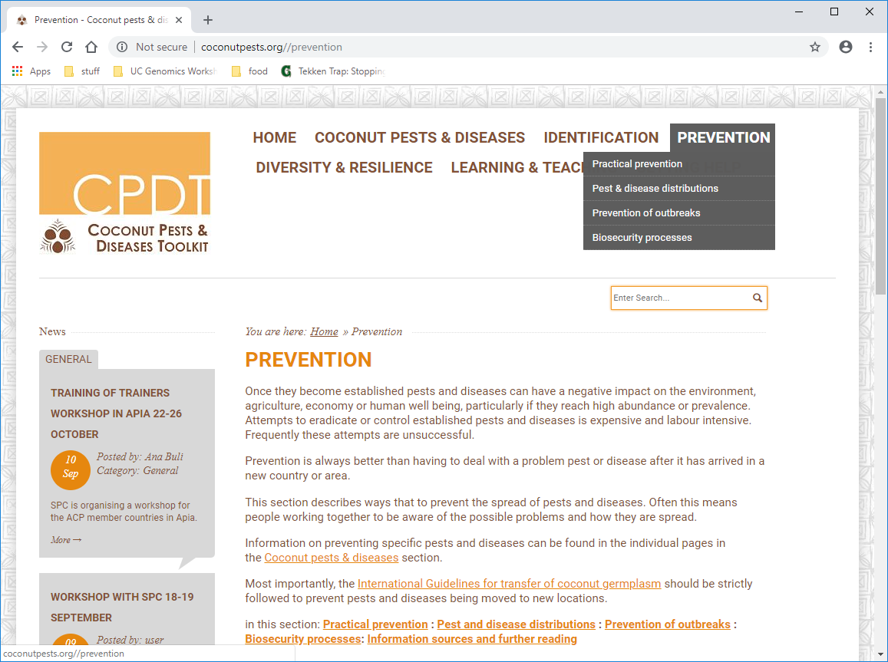

Click on the PREVENTION section heading in the navigation bar. Like the COCONUT PESTS & DISEASES pages for individual pests and diseases, the information is broken down into topics on the page. These are:
- Practical prevention.
- Prevention of outbreaks.
- Pest & disease distributions.
- Biosecurity processes
- Information sources and further reading.
Some of the sections have a practical focus and are primarily intended for use by farmers and members of the community. Others are more targeted to biosecurity and agriculture officers.

Individual Activity – Pest & disease distributions
Key pieces of knowledge for prevention are knowing what pests and diseases are present in your country (i.e. biosecurity is around to domestic transport and movement control, which can be very difficult to enforce) and knowing what pests and diseases your trading countries have (i.e., biosecurity needs to include international border points).
In this exercise, you are going to use the Excel distribution workbook in the Pest and Disease distributions sub-section to find out information on:
- The distribution of a specific pest (or disease).
- Which pests & diseases are in your country.
- Which pests & diseases are in selected trading partners – you choose one or two countries.
We will spend around 30 minutes on this activity. Find and download the Excel workbook of coconut pest & disease distributions.
Click on the Pest & disease distributions link (from either the drop-down list in the navigation bar - faster - or through the PREVENTION page links).
Once the Excel workbook is downloaded and opened you must click “Enable Editing” to use the filters. You can open the workbook a ‘read-only’ if you wish, but you can also make changes. Save the worksheet onto your computer.
You will see that there are many worksheets in the workbook. The worksheet called ‘combined’ is a summary of all the other sheets and this is what you will be working with. The other worksheets are the source information for the combined worksheet.
Are you familiar with filters? Filters have been set on this worksheet. Filters allow you to view subsets of information, and are indicated with an arrow on each cell of the heading row: 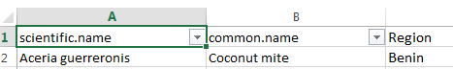

If you click on the arrow a drop-down list will appear that shows all the options for that column.
All the options with a tick will be shown and the other options will be filtered out.
Try filtering the column headed common.name so that you see only Cacao mealybug.
HINT: First untick the (Select all) option at the top of the list
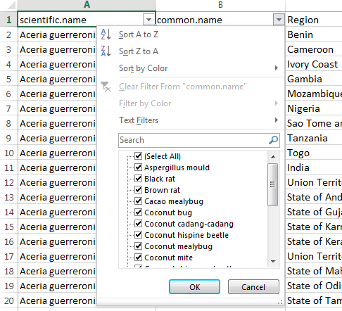

The distribution of a specific pest
You know that red palm weevil is a pest that you don’t want in your country.
Now you need to work out where it might come from. Imagine your country only imports goods from the following countries:
China | Australia | New Zealand | United States | Taiwan | Japan
Use the Excel spreadsheet to identify which of these countries red palm weevil might come from. Circle these countries in the list above.
If you wanted to find out all countries that red pam weevil is absent from, how would you do this using the worksheet?

Which pests & diseases are in your country and selected trading partners
Now use the filters (on the Region column) to find out which pests and diseases are in your country. Place a tick or cross in the appropriate cell in the table below. Then find information on trading partners.
- Pest / disease | - In my country? | - Trading partner 1: | - Trading partner 2: | - Trading partner 2:
  - Coconut mite
  - Coconut bug
  - Aspergillus mould
  - Coconut scale
  - Coconut hispine beetle
  - Coconut cadang-cadang
  - Pineapple mealybug
  - Striped mealybug
  - Lethal yellowing Host
  - Coconut mealybug
  - Coconut rhinoceros beetle
  - Lethal yellowing
  - Cacao mealybug
  - Red palm mite
  - Red ring nematode
  - Polynesian rat
  - Brown rat
  - Black rat
  - Red palm weevil

Group Activity – finding information on prevention
As with the previous group exercises, you will review the information on the pages and share with the rest of the workshop. As there is a lot more information in the biosecurity processes, this section will be divided between two groups (pre-border and post-border), and we will not cover at-border activities. WE will break up into four groups.
Each group should list:
- What works well in their countries?
- What could be improved (see the information in the toolkits to get you thinking)?
- What are the barriers to improvement?
After 20 minutes each group will then report back to the workshop. Make your own notes for each section below.
  - Notes: Practical prevention
  - Notes: Prevention of outbreaks
  - Notes: Biosecurity processes – pre-border
  - Notes: Biosecurity processes – post-border

Exercise 6: Practical prevention
Duration: 1.5 hours
Objective: Know practical ways to prevent pests and diseases using examples

Group Activity – practical prevention of CRB
In this exercise we will expand on the work done in Exercise 5, to come up with practical ideas that can be incorporated into prevention plans for each country, using CRB as a case study. We will do this in three groups and participants from Solomon Islands, Palau and Papua New Guinea will act as mentors for each of the three groups (because CRB-G is in all these countries).
- What specific activities are currently happening in your country for CRB prevention?
- What should be happening?
- What are the barriers?
Focus on overcoming barriers to prevention of CRB (spread of CRB-S/CRB-G and entry of CRB-G), like availability of tools, resources, lack of knowledge, funding or lack of stakeholder awareness.
After around 30-40 minutes discussion in the 3 groups, groups will present on their countries, and then we will look for gaps where regional biosecurity could be improved, and biosecurity strengths for the region.
You can use the space here to make notes for each country, and gaps and strengths for the region.

In-country CRB prevention activities
- Country | - Current activities | - What should be happening | - Barriers
  - Cook Islands
  - Federated States of Micronesia
  - Fiji
  - Kiribati
  - Marshall Islands
  - Nauru
  - Niue
  - Palau
  - Papua New Guinea
  - Samoa
  - Solomon Islands
  - Timor Leste
  - Tonga
  - Tuvalu
  - Vanuatu
  - Tokelau

Region – gaps and strengths
Do these regional strengths and gaps apply for other pests and diseases?
- Gaps | - Strengths
Final discussion point: Discuss current active early detection rapid response actions for any pest or disease (surveillance and having response resources ready to be mobilised).
If we have time, and participants wish, we can repeat this exercise with other pests or diseases.
  - Notes

Day four
Recap from Day two.
- Prevention is key.
- Practical prevention.

Exercise 7: Pest and disease control
Duration: 1.5 hours
Objective: Know practical ways to control key pests and diseases through examples
We will work through another group activity and in the afternoon we will return to where we put out our bucket traps for CRB.

Group Activity – methods and barriers to pest control
In this exercise we explore control methods for some key pests – all of which are present in many places in the Pacific, to come up with practical ideas that can be shared with stakeholders for each country. We will do this in four groups. If you have had experience with control of one of the pests, please join that group to help others. The pests we will focus on are:
- Coconut rhinoceros beetle – Oryctes rhinoceros.
- Coconut scale / false scale.
- Rats.
- Mealybugs.
Discuss the following topics in your group and make notes as a group:
- What are practical control methods (cultural / natural / chemical) you would use for this pest? Use your group’s own knowledge and the information in the COCONUT PESTS & DISEASES pages.
- What are the barriers to control of this pest in your country, like availability of tools, resources, lack of knowledge, or lack of support (e.g. from the community, businesses or government)?
After around 30 minutes of discussion in the 4 groups, groups will present, and then we discuss how barriers to control can be overcome. You can use the space here to make notes for each pest.

Coconut rhinoceros beetle – Oryctes rhinoceros
Control methods | Barriers to effective control | Ideas for removing barriers

Coconut scale / false scale
Control methods | Barriers to effective control | Ideas for removing barriers

Rats
Control methods | Barriers to effective control | Ideas for removing barriers

Mealybugs
Control methods | Barriers to effective control | Ideas for removing barriers

Exercise 8: Diversity and resilience
Duration: 1 hour
Objective: Understand the importance of diversity to resilience
Hover over the DIVERSITY & RESILIENCE section heading in the navigation bar. There is a single page of information on diversity and resilience, so no drop-down list appears.
Click on the DIVERSITY & RESILIENCE section heading in the navigation bar.
The following page appears. Unlike the PREVENTION and other pages, the information is not broken down into topics on the page.
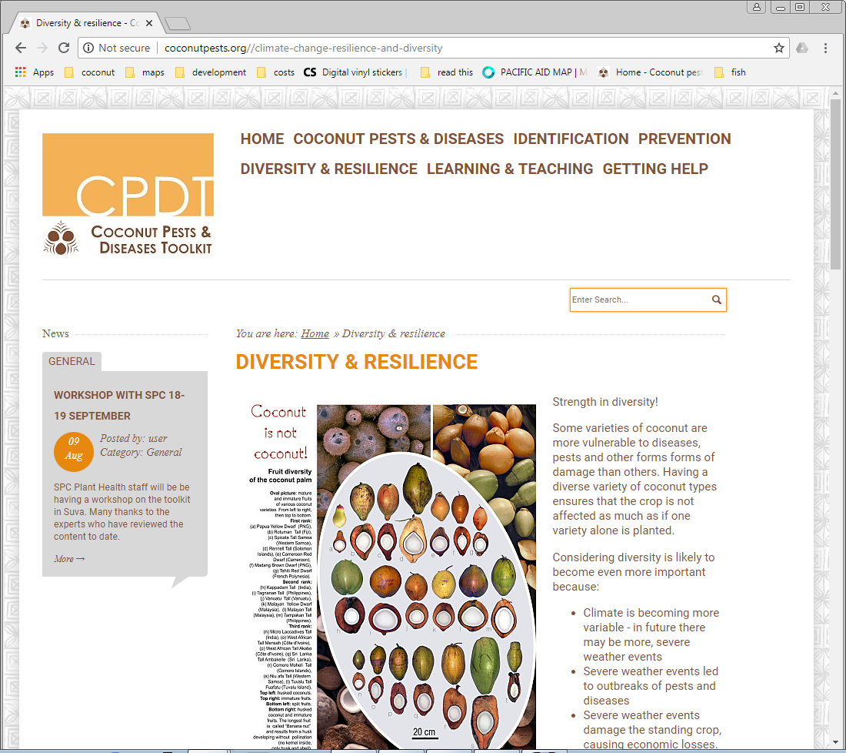

Group Activity – the importance of diversity
Again, we will get into groups and discuss the following questions for around 30 minutes, and then report back to the group. Use these questions to guide your discussions:
- Why do you think diversity important?
- What do you (or others in your country) do to promote diversity and resilience?
- Check out the information on the Polymotu concept. Is a similar approach used in your country?
- What would you advise local growers to do to increase resilience?
- Some varieties are suggested for disease resistance. Do you have these varieties?
- Are there other varieties you would suggest?
Make notes on diversity below:
  - Why do you think diversity important?
  - What do you (or others in your country) do to promote diversity and resilience?
  - Check out the information on the Polymotu concept. Is a similar approach used in your country?
  - What would you advise local growers to do to increase resilience?
  - Some varieties are suggested for disease resistance. Do you have these varieties?
  - Are there other varieties you would suggest?

Exercise 9: Community awareness
Duration: 1 hour
Objective: Think about ways that increased community awareness can help prevent and control diseases and pests
Hover over the LEARNING & TEACHING section heading in the navigation bar. There is a drop-down list of the two different pages in this sections: Awareness materials and Workshop resources.
The Workshop resources incudes the workbook for this workshop. We have provided it so people can work through the toolkit in their own time, and for trainers to use to lead workshops.
For now, we will only focus on the Awareness materials.
Click on the Awareness materials link in the drop-down list (or in the LEARNING & TEACHING section main page).
The following page appears.
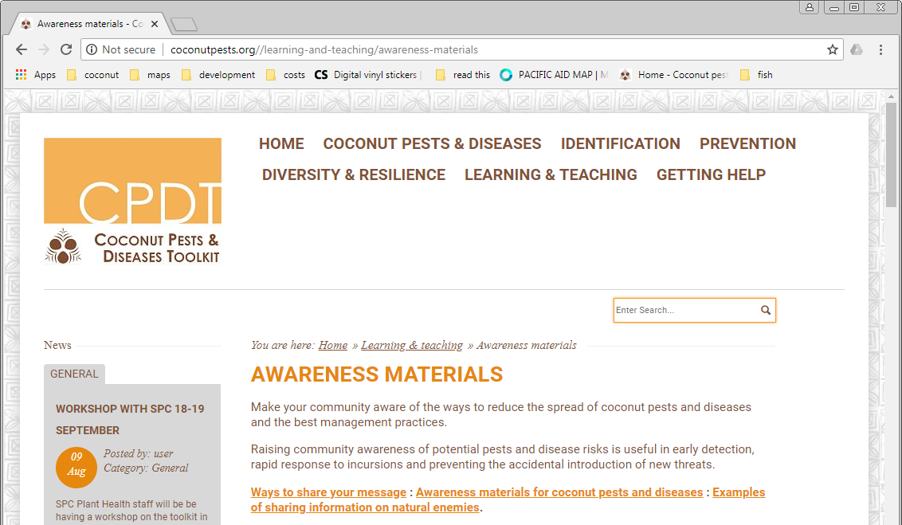

Like the PREVENTION page, the information is broken down into topics on the page. These are:
- Ways to share your message.
- Awareness materials for coconut pests and diseases.
- Examples of sharing information on natural enemies.

Small Group Activity – create a poster to raise awareness
We will break into groups of 2-3 people for this activity. If you are keen to make your very own poster, you can work alone if you wish.
In this activity you will use a template and information in the toolkit to create a poster for community awareness on a pest or disease of your choice!
The toolkit has a PowerPoint template for making awareness posters. Find the link in the Ways to share your message information and click to download. When you open the template you will need to ‘Enable Editing’ so you can make changes to the poster. Save the template onto your computer. The template has an information page, which you can delete once you have read it.

At the moment the template has information on CRB. You can keep this for your reference, copy the slide, and then make changes for the pest or disease you have chosen.
You can make the poster bilingual, or in whichever language you think is more useful.
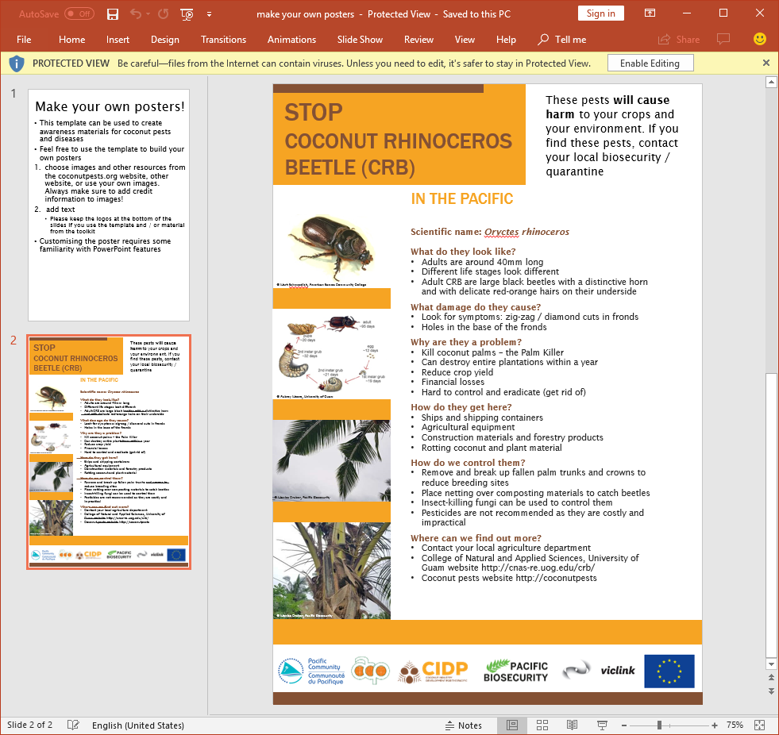
We will spend about 40 minutes making posters.
Afterwards we will talk as a whole group about why we chose the pest or disease, and some other ways to raise awareness.
Make notes below:

Version control
author | Description | date
Monica Gruber | Version v1 | 10 September 2018
Monica Gruber | Version v2: changes from SPC initial review | 3 October 2018
Monica Gruber | Version v3: various updates to Exercises | 16 October 2018

